**Target Journals:**

**Title**:Rhizobial inoculation and CO2 concentration modify *Glycine max* photosynthetic and growth responses to soil nitrogen fertilization

**Running Head:**

**Author List:** Evan A. Perkowski, Nicholas G. Smith

**Author Affiliations:** Department of Biological Sciences, Texas Tech University, Lubbock, TX

**Manuscript compilation details**

**Abstract:** XX words

**Main text word count**: XX words

Introduction: XX words

Methods: 3352 words

Results: 1757 words (not including text in figures or tables)

Discussion: XX words (XX% of total word count)

**References**: XX

**Tables and Figures**: 6 tables and 6 figures

**Supplemental Information**:

**Abstract**

Plants acclimate to increasing CO2 by reducing leaf nutrient allocation and photosynthetic capacity at the leaf level, a response that often occurs alongside growth stimulation at the whole plant level. Nutrient limitation has been hypothesized to be the primary driver of plant acclimation to CO2, as nutrient availability commonly limits primary productivity and may decrease with increasing CO2 over time. However, recent work leveraging photosynthetic least-cost theory indicates that these acclimation responses may instead be the result of optimal resource investment toward photosynthetic capacity, which maximizes nutrient allocation to whole plant growth. To understand whether nutrient limitation or optimal leaf resource investment controls plant acclimation to CO2 and how nutrient acquisition strategy modifies these responses, we grew soybean under two atmospheric CO2 levels, two inoculation treatments, and nine soil nitrogen fertilization treatments in a full factorial growth chamber experiment.

We found that …

These results suggest that XX is the dominant control of plant acclimation responses to CO2, providing important empirical data needed to refine our understanding of mechanisms driving plant acclimation to CO2.

**Keywords**

photosynthetic acclimation, soil nutrient availability, nutrient acquisition, global change

**Introduction**

[thoughts: soil N fertilization forward, then discuss how CO2 and inoculation may modify expected acclimation responses to soil N fertilization]

**Methods**

*Seed treatments and experimental design*

*Glycine max* L. (Merr) seeds were planted in 144 6-liter surface sterilized pots (NS-600, Nursery Supplies, Orange, CA, USA) containing a steam-sterilized 70:30 v:v mix of *Sphagnum* peat moss (Premier Horticulture, Quakertown, PA, USA) to sand (fill in manufacturer info here). Before planting, all *G. max* seeds were surface sterilized in 2% sodium hypochlorite for 3 minutes, followed by three separate 3-minute washes with ultrapure water (MilliQ 7000; MilliporeSigma, Burlington, MA USA). A subset of surface sterilized seeds were then inoculated with *Bradyrhizobium japonicum* (Verdesian N-Dure™ Soybean, Cary, NC, USA) in a slurry following manufacturer recommendations (3.12 g inoculant and 241 g deionized water per 1 kg seed).

Seventy-two pots were randomly planted with seeds inoculated with *B.* *japonicum* and 72 pots were planted with uninoculated seeds. Thirty-six pots within each inoculation treatment were randomly placed in one of two atmospheric CO2 treatments (ambient and 1000 μmol mol-1 CO2). Pots within each unique inoculation-by- CO2 treatment combination randomly received one of nine soil nitrogen fertilization treatments equivalent to 0, 35, 70, 105, 140, 210, 280, 350, or 630 ppm N. Nitrogen fertilization treatments were created using a modified Hoagland solution (Hoagland & Arnon, 1950) and were designed to keep concentrations of other macronutrients and micronutrients equivalent across treatments (Table S1). Fertilization treatments were applied twice per week in 150mL doses as topical agents to the soil surface throughout the duration of the experiment.

*Growth chamber conditions*

Upon experiment initiation, pots were randomly placed in one of six Percival LED-41L2 growth chambers (Percival Scientific Inc., Perry, IA, USA). The experiment was conducted over two iterations due to chamber space limitation. The two iterations were conducted such that one iteration included all elevated CO2 pots and the second iteration included all ambient CO2 pots. CO2 concentrations for the ambient CO2 treatment averaged 439±5 μmol mol-1 CO2, while the CO2 concentrations for the elevated CO2 treatment averaged 989±4 μmol mol-1 CO2.

Daytime growing conditions were simulated using a 16-hour photoperiod, with incoming light radiation set to chamber maximum (mean±SD: 1240±32 μmol m-2 s-1 across chambers), air temperature set to 25°C, and relative humidity set to 50%. The remaining 8 hours simulated nighttime growing conditions, with incoming light radiation set to 0 μmol m-2 s-1, chamber temperature set to 17°C, and relative humidity set to 50%. Transitions between daytime and nighttime growing conditions were simulated by ramping incoming light radiation in 45-minute increments and temperature in 90-minute increments over a 3-hour period (Table S2).

Including the two 3-hour ramping periods, pots grew under average (± SD) daytime light intensity of 1049±27 μmol m-2 s-1. In the elevated CO2 iteration, pots grew under 24.0±0.2°C during the day, 16.4±0.8°C during the night, and 51.6±0.426% relative humidity. In the ambient CO2 iteration, pots grew under 23.9±0.2°C during the day, 16.0±1.4°C during the night, and 50.3±0.2% relative humidity. We attempted to account for any climatic differences across the six chambers by shuffling the same group of pots throughout the growth chambers. This was done by iteratively moving pots on the top rack of a chamber to the bottom rack and pots on the bottom rack of a chamber to the top rack of the adjacent chamber. We moved pots within and across chambers every day throughout the course of each experiment iteration.

*Leaf gas exchange measurements*

Gas exchange measurements were collected on the most recent fully expanded leaf for all experimental pots on the seventh week of development. Specifically, we measured net photosynthesis (*A*net; μmol m-2s-1), stomatal conductance (*g*s; mol m-2s-1), and intercellular CO2 (*C*i; μmol mol-1) concentrations across a range of atmospheric CO2 concentrations (i.e. an *A*net/*C*i curve) using the Dynamic Assimilation Technique™. The Dynamic Assimilation Technique™ has been shown to correspond well with traditional steady-state CO2 response curves in *G. max* (Saathoff & Welles, 2021). *A*net/*C*i curves were generated using the split method, which measured *A*net, *g*s, and *C*i along a reference CO2 ramp down from 420 µmol mol-1 CO2 to 20 µmol mol-1 CO2, followed by a ramp up from 420 µmol mol-1 CO2 to 1620 µmol mol-1 CO2 after a 90-second wait period at 420 µmol mol-1 CO2. The ramp rate for each curve was set to 200 μmol mol-1 min-1, logging every five seconds, which generated 96 data points per response curve. All *A*net/*C*i curves were generated with the cuvette flow rate stabilized at 500 mol s-1, mixing fan set to 10,000 rpm, vapor pressure deficit set to 1.5 kPa, leaf temperature set to 25°C, and incoming light radiation set to 2000 μmol m-2 s-1.

Using the same focal leaf as the one used to generate *A*net/*C*i curves, we measured dark respiration (*R*d; μmol m-2 s-1) following at least a 30-minute period of darkness. Measurements were collected on a 5-second log interval for 60 seconds after stabilizing in a LI-6800 cuvette set to a 500 mol s-1 flow rate, 10,000 rpm mixing fan speed, 1.5kPa vapor pressure deficit, and 25°C leaf temperature, with reference CO2 stabilized at 420 µmol mol-1 CO2 and incoming light radiation set to 0 μmol m-2 s-1. A single dark respiration value was determined for each focal leaf by calculating the mean dark respiration value across the logging interval.

*Leaf trait measurements*

At the end of the seventh week of the experiment, leaf trait measurements were collected on the same focal leaf used to generate *A*net/*C*i response curves. Images of each leaf were curated using a flat-bed scanner to determine wet leaf area using the 'LeafArea' R package (Katabuchi, 2015), which automates leaf area calculations using ImageJ software (Schneider, Rasband, & Eliceiri, 2012). Each leaf was dried at 65C for at least 48 hours, and subsequently weighed and ground until homogenized. Leaf mass per area (*M*area; g m-2) was calculated as the ratio of dry leaf biomass to fresh leaf area. Using subsamples of ground and homogenized leaf biomass, we measured leaf nitrogen content (*N*mass; g g-1) through elemental combustion analysis (Costech-4010, Costech, Inc., Valencia, CA, USA), and sent samples to the University of California-Davis Stable Isotope Facility to determine leaf δ13C and δ15N. Leaf nitrogen content per unit leaf area (*N*area; gN m-2) was calculated by multiplying *N*mass and *M*area.

We used leaf δ13C values to estimate the ratio of intercellular (*C*i) to extracellular (*C*a) CO2 (χ; unitless) following the approach of Farquhar *et al.* (1989) described in Cernusak *et al.* (2013). While intercellular and extracellular CO2 concentrations were directly measured during each CO2 response curve, deriving χ from δ13C provides a more integrative estimate of the *C*i:*C*a over an individual leaf’s lifespan. We derived χ as:

(1)

Δ13C represents the relative difference between leaf δ13C (δ13Cleaf; ‰) and air δ13C (δ13Cair; ‰), and is calculated from the following equation:

$Δ^{13}C=\frac{δ^{13}C_{air}-δ^{13}C_{leaf}}{1+δ^{13}C_{leaf}}$ (2)

In Equation 1, *a* represents the fractionation between 12C and 13C due to diffusion in air, assumed to be 4.4‰, and *b* represents the fractionation caused by Rubisco carboxylation, assumed to be 27‰ (Farquhar et al., 1989). We expected δ13Cair to differ across chambers and by atmospheric CO2 concentration, so we sent sealed chamber gas samples to the University of California-Davis Stable Isotope Facility to determine δ13Cair. Specifically, we sent three samples from each chamber at each CO2 treatment, then used the average δ13C across machines for each CO2 treatment to derive δ13Cair. From this, δ13Cair was set to XX‰ for the elevated CO2 treatment and XX‰ for the ambient CO2 treatment. This process allows us to make better inferences that changes in stomatal conductance were the proximal cause of shifts in *χ*.

We extracted chlorophyll content from a second leaf in the same trifoliate leaf set as the focal leaf used to generate *A*net/*C*i curves. Prior to chlorophyll extraction, we used a cork borer to punch between 3 and 5 0.6 cm2 disks from the leaf. Separate images of each punched leaf and set of leaf disks were curated using a flat-bed scanner to determine wet leaf area, again quantified using the 'LeafArea' R package (Katabuchi, 2015). The punched leaf was dried and weighed after at least 65°C in the drying oven, with leaf mass per area calculated as a function of dry biomass and wet leaf area.

Leaf disks were shuttled into a test tube containing 10mL dimethyl sulfoxide, vortexed, and incubated at 65°C for 120 minutes (Barnes, Balaguer, Manrique, Elvira, & Davison, 1992). Incubated test tubes were then vortexed and loaded in 150 μL triplicate aliquots on to a 96-well plate. Dimethyl sulfoxide was also loaded in a single 150 μL triplicate aliquot as a blank. Absorbance measurements at 649.1 nm (*A*649.1) and 665.1 nm (*A*665.1) were read in each well using a plate reader (Biotek Synergy H1; Biotek Instruments, Winooski, VT USA) (Wellburn, 1994), with triplicates subsequently averaged and corrected by the mean of the blank absorbance. Blank-corrected absorbance values were used to estimate *Chl*a (μg mL-1) and *Chl*b (μg mL-1) following equations from Wellburn (1994):

${Chl}_{a}=12.47A_{665.1}-3.62A_{649.1}$ (3)

and

${Chl}_{b}=25.06A_{649.1}-6.5A_{665.1}$ (4)

*Chl*a and *Chl*b were converted to mmol mL-1 using the molar mass of chlorophyll *a* (893.51 g mol-1) and the molar mass of chlorophyll *b* (907.47 g mol-1), then added together to calculate total chlorophyll content in the dimethyl sulfoxide extractant (mmol mL-1). Total chlorophyll content was then multiplied by the volume of the dimethyl sulfoxide extractant (10mL) and converted to area-based chlorophyll content (*Chl*area; mmol m-2). Mass-based chlorophyll content (*Chl*mass; mmol g-1) was also calculated by dividing *Chl*area by the leaf mass per area of the punched leaf.

*A*/*C*i *curve-fitting and parameter estimation*

We fit *A*net/*C*i curves of each individual using the ‘fitaci’ function in the ‘plantecophys’ R package (Duursma, 2015). This function estimates the maximum rate of Rubisco carboxylation (*V*cmax; µmol m-2 s-1) and maximum rate of electron transport for RuBP regeneration (*J*max; µmol m-2 s-1) based on the Farquhar, von Caemmerer, and Berry biochemical model of C3 photosynthesis (Farquhar, von Caemmerer, & Berry, 1980). Triose phosphate utilization (TPU) limitation and dark respiration were included in all curve fits. We determined Michaelis-Menten coefficients for Rubisco affinity to CO2 (*K*c; μmol mol-1) and O2 (*K*o; mmol mol-1), and the CO2 compensation point *(Γ*\*; μmol mol-1) using leaf temperature and equations described in Medlyn et al. (2002) and derived in Bernacchi et al. (2001). Specifically, *K*c and *K*o were calculated as:

$K_{c}={404.9*exp}^{\left(\frac{79430(T_{k}-298)}{298RT_{k}}\right)}$ (5a)

and

$K_{o}={278.4*exp}^{\left(\frac{36380(T_{k}-298)}{298RT_{k}}\right)}$ (5b)

while *Γ*\* was calculated as:

$Γ^{*}={42.75*exp}^{\left(\frac{37830(T_{k}-298)}{298RT_{k}}\right)}$ (5c)

In all three equations, *T*k is the leaf temperature (in Kelvin) during each CO2 response curve and R is the universal gas constant (8.314 J mol-1 K-1).

*V*cmax, *J*max, and *R*d were estimated using measurements that were collected at a common leaf temperature (25°C). Therefore, there was no need to manually standardize rate estimates to a single temperature, and are referenced throughout the rest of the paper as *V*cmax25, *J*max25, and *R*d25.

*Stomatal limitation*

We quantified the extent by which stomatal conductance limited photosynthesis (*l*; unitless) following equations originally described in Farquhar & Sharkey (1982). Stomatal limitation is calculated as:

$l=1-\frac{A_{net}}{A_{mod}}$ (6)

*A*net represents the net photosynthesis rate where reference CO2 was set to 420 μmol mol-1 CO2, while *A*mod represents the photosynthetic rate where *C*i = *C*a. *A*mod was calculated as:

$A_{mod}=V_{cmax}\frac{400-Γ^{*}}{400+Κ_{m}}-R_{d}$ (7)

Γ* (μmol mol-1) is the CO2 compensation point in the absence of dark respiration, while *K*m is the Michaelis-Menten coefficient for Rubisco-limited photosynthesis. *K*m was calculated as:

$K_{m}=K_{c}*\left(1+\frac{O_{i}}{K_{o}}\right)$ (8)

*K*c refers to the Michaelis-Menten coefficient for Rubisco affinity to CO2, *K*o refers to the Michaelis-Menten coefficient for Rubisco affinity to O2, and *O*i refers to leaf intercellular O2 concentrations. Γ* and *K*c were standardized according to Equations 5c and 5a.

*Proportion of leaf nitrogen allocated to photosynthesis and structure*

We used equations from Niinemets & Tenhunen (1997) and to estimate the proportion of leaf nitrogen content allocated to Rubisco, bioenergetics, and light harvesting proteins. Specifically, the proportion of leaf nitrogen allocated to Rubisco (ρrubisco; gN gN-1) was calculated as a function of *V*cmax25 and *N*area:

(9)

where *N*r is the amount of nitrogen in Rubisco, set to 0.16 gN (gN in Rubisco)-1 and *V*cr is the maximum rate of RuBP carboxylation per unit Rubisco protein, set to 20.5 μmol CO2 (g Rubisco)-1. The proportion of leaf nitrogen allocated to bioenergetics (ρbioenergetics; gN gN-1) was similarly calculated as a function of *J*max25 and *N*area:

(10)

where *N*b is the amount of nitrogen in cytochrome f, set to 0.12407 gN (μmol cytochrome f)-1 assuming a constant 1: 1: 1.2 cytochrome f: ferredoxin NADP reductase: coupling factor molar ratio (Evans & Seemann, 1989; Niinemets & Tenhunen, 1997), and *J*mc is the capacity of electron transport per cytochrome f, set to 156 μmol electron (μmol cytochrome f)-1 s-1. The proportion of leaf nitrogen allocated to light harvesting proteins was calculated as a function of

*Chl*mass and *N*mass:

(11)

where *c*b is the stoichiometry of the light-harvesting chlorophyll complexes of photosystem II, set to 2.75 mmol chlorophyll (gN in chlorophyll)-1. We used the *N*mass value of the focal leaf used to generate *A*net/*C*i curves instead of the leaf used to extract chlorophyll content, as the two leaves are from the same trifoliate leaf set and are highly correlated with each other (Figure SX).

The proportion of leaf nitrogen content allocated to photosynthetic tissue (ρphoto; gN gN-1) was estimated as the sum of ρrubisco, ρbioenergetics, and ρlight. Finally, the proportion of leaf nitrogen content allocated to structural tissue (*ρ*structure; gN gN-1) was estimated using an empirical equation from Onoda *et al.* (2017):

$N_{cw}=0.000355*{M_{area}}^{1.39}$ (9)

where *N*cw (gN m-2) is the leaf nitrogen content allocated to cell walls and *M*area (g m-2) is the leaf mass per area. *ρ*structure was estimated by dividing estimated *N*cw by measured *N*area.

*Tradeoffs between nitrogen and water use*

Photosynthetic nitrogen use efficiency (*PNUE*; µmol CO2 mol N-1 s-1) was calculated by dividing *A*net measured at 420 μmol mol-1 CO2 by *N*area, where the numerator (gN) was converted to mol N by dividing by 14 gN mol-1 N. We used χ, mentioned above, to estimate water use efficiency. Tradeoffs between nitrogen and water use were determined by calculating the ratio of *N*area toχ (*N*area: χ; gN m-2) and *V*cmax25 to χ(*V*cmax: χ; μmol m-2s-1).

*Whole plant traitsvfgc*

Seven weeks after experiment initiation, we harvested all experimental individuals and separated biomass of each experimental individual into major organ types (leaves, stems, roots, and root nodules when present). Fresh leaf area of all harvested leaves was measured using an LI-3100C (Li-COR Biosciences, Lincoln, Nebraska, USA). Total fresh leaf area (cm2) was calculated as the sum of all leaf areas, and included the focal leaf used for the *A*net/*C*i curve and the focal leaf used to extract chlorophyll content. All harvested material was dried in an oven set to 65°C for at least 48 hours, weighed, and ground to homogeneity. Leaves and nodules were manually ground either with a mortar and pestle, while stems and roots were ground in a Wiley mill (E3300 Mini Mill; Eberbach Corp., MI, USA). Total dry biomass (g) was calculated as the sum of dry leaf (including focal leaf for both the *A*net/*C*i curve and leaf used to extract chlorophyll content), stem, root, and root nodule biomass. We also quantified carbon and nitrogen content of each respective organ type through elemental combustion (Costech-4010, Costech, Inc., Valencia, CA, USA) using subsamples of ground and homogenized organ tissue.

Following the approach explained in Perkowski *et al.* (2021), we calculated structural carbon costs to acquire nitrogen as the ratio of total belowground carbon biomass to whole plant nitrogen biomass (*N*cost; gC g-1N). Belowground carbon biomass (*C*bg; gC) was calculated as the sum of root carbon biomass and root nodule carbon biomass. Root carbon biomass and root nodule carbon biomass was calculated as the product of the organ biomass and the respective organ carbon content. Whole-plant nitrogen biomass (*N*wp; gN) was similarly calculated as the sum of total leaf, stem, root, and root nodule nitrogen biomass, including the focal leaf used for *A*net/*C*i curve and chlorophyll extractions. Leaf, stem, root, and root nodule nitrogen biomass was calculated as the product of the organ biomass and the respective organ nitrogen content. This calculation only quantifies plant structural carbon costs to acquire nitrogen and does not include any additional carbon costs of nitrogen acquisition that are associated with respiration, root exudation, or root turnover. An explicit explanation of the limitations for interpreting this calculation can be found in Perkowski *et al.* (2021) and Terrer *et al.* (2018).

*Nitrogen fixation*

We calculated plant investments in nitrogen fixation as the ratio of root nodule biomass to root biomass, where increasing values indicate an increase in plant investments to nitrogen fixation (Dovrat, Bakhshian, Masci, & Sheffer, 2020; Dovrat et al., 2018; Perkowski et al., 2021). We also calculated the percent of leaf nitrogen acquired from the atmosphere (%Ndfa) using leaf δ15N and the following equation from Andrews et al. (2011):

$\% Nfda=\frac{δ^{15}N_{reference}-δ^{15}N_{sample}}{δ^{15}N_{reference}-B}$ (Eqn. 11)

where δ15Nreference refers to a reference plant that exclusively acquires nutrients via direct uptake, δ15Nsample refers to an individual’s leaf δ15N, and B refers to individuals that are entirely reliant on nitrogen fixation.

Within each nitrogen fertilization treatment x CO2 treatment combination (n=18), we calculated the mean leaf δ15N for individuals growing in the non-inoculated treatment for δ15Nreference. Any individuals with visual confirmation of root nodule formation or nodule initiation were omitted from the calculation of δ15Nreference. Following recommendations from Andrews et al. (2011) we calculated B within each CO2 treatment by calculating the mean leaf δ15N of inoculated individuals that formed nodules. We did not calculate B within each unique soil nitrogen x CO2 treatment combination, as previous studies suggest decreased reliance on nitrogen fixation with increasing soil nitrogen availability (Perkowski et al., 2021). This approach for estimating nitrogen fixation standardizes values such that approaching 1 indicates increasing reliance on nitrogen fixation, while values that approach 0 indicate decreasing reliance on nitrogen fixation.

*Statistical analyses*

Any uninoculated pots that had substantial root nodule formation (>0.05g root nodule biomass) were removed from our analyses. This decision resulted in the removal of sixteen pots from our analysis: two pots in the elevated CO2 treatment that received 35 ppm N, three pots in the elevated CO2 treatment that received 70 ppm N, one pot in the elevated CO2 treatment that received 210 ppm N, two pots in the elevated CO2 treatment that received 280 ppm N, two pots in the ambient CO2 treatment that received 0 ppm N, three pots in the ambient CO2 treatment that received 70 ppm N, two pots in the ambient CO2 treatment that received 105 ppm N, and one pot in the ambient CO2 treatment that received 280 ppm N. The removal of these pots allows for the better detection of inoculation treatment effects on measured leaf and whole plant traits and does not influence statistical power to a large extent due to the inclusion of nitrogen fertilization treatment as a continuous variable in our statistical models.

We built a series of linear mixed effects models to investigate the impacts of atmospheric CO2, soil nitrogen fertilization, and inoculation with *B. japonicum* on *G. max* leaf photosynthesis, tradeoffs between nitrogen and water use, whole plant growth, plant investment in nitrogen fixation, and percent nitrogen fixed from the atmosphere. All models included CO2 treatment as a categorical fixed effect, inoculation treatment as a categorical fixed effect, soil nitrogen fertilization as a continuous fixed effect, with interaction terms between all three fixed effects. All models also accounted for unexplained variance due to experiment iteration and starting rack by including a nested chamber rack-by-CO2 treatment random intercept term. Models with this independent variable structure were created for each of the following dependent variables: *N*cost, *C*bg, *N*wp, total biomass, total leaf area, root nodule biomass, the ratio of root nodule biomass to root biomass, *%N*dfa, *N*area, *M*area, *N*mass, *Chl*area, *V*cmax25, *J*max25, *J*max25:*V*cmax25, *R*d25, *g*sw, *C*i:*C*a, stomatal limitation, *ρ*rubisco, *ρ*bioe, *ρ*light, *ρ*photo, *ρ*structure, *χ*, *PNUE*, *iWUE*, *N*area:*g*sw, and *V*cmax25:*g*sw.

We used Shapiro-Wilk tests of normality to determine whether linear mixed-effects models satisfied residual normality assumptions. If residual normality assumptions were not met (Shapiro-Wilk: p<0.05), then models were fit using dependent variables that were natural log transformed. If residual normality assumptions were still not met (Shapiro-Wilk: p<0.05), then models were fit using dependent variables that were square root transformed. All residual normality assumptions that did not originally satisfy residual normality assumptions were met with either a natural log or square root data transformation (Shapiro-Wilk: p>0.05 in all cases). Specifically, models for total leaf area, *N*area, *N*mass, *Chl*area, *V*cmax25, *J*max25, *J*max25:*V*cmax25, *C*i:*C*a, stomatal limitation, *ρ*photo, *ρ*rubisco, *ρ*bioe, *PNUE*, and *iWUE*, satisfied residual normality assumptions without data transformation. Models for *N*cost, *C*bg, *N*wp, total biomass, *M*area, *N*area:*g*s, and *V*cmax:*g*s, *ρ*structure, satisfied residual normality assumptions with a natural log data transformation, and models for *g*sw and *ρ*light satisfied such assumptions with a square root data transformation.

In all statistical models, we used the 'lmer' function in the 'lme4' R package (Bates, Mächler, Bolker, & Walker, 2015) to fit each model and the 'Anova' function in the 'car' R package (Fox & Weisberg, 2019) to calculate Type II Wald's χ2 and determine the significance (α=0.05) of each fixed effect coefficient. We then used the 'emmeans' R package (Lenth, 2019) to conduct post-hoc comparisons using Tukey's tests, where degrees of freedom were approximated using the Kenward-Roger approach (Kenward & Roger, 1997). All analyses and plots were conducted in R version 4.2.0 (R Core Team, 2021).

**Results**

*Carbon costs to acquire nitrogen*

Carbon costs to acquire nitrogen were driven by a three-way interaction between CO2 treatment, inoculation treatment, and nitrogen fertilization (Table 1; Fig. 1A). This interaction indicated that increasing nitrogen fertilization decreased *N*cost in all treatment combinations, except for inoculated pots growing in the elevated CO2 treatment (Tukey: p=0.827; Fig. 1A). A strong interaction between inoculation treatment and nitrogen fertilization indicated that the general negative effect of increasing fertilization on *N*cost was stronger in uninoculated pots (Tukey: p<0.001; Table 1). An additional interaction between CO2 and inoculation treatments indicated that inoculation treatment had no effect on *N*cost in the ambient CO2 treatment (Tukey: p=0.227), while uninoculated pots generally had higher *N*cost than inoculated pots in the elevated CO2 treatment (Tukey: p<0.001). Individually, *N*cost generally increased with increasing CO2 concentration, decreased with inoculation, and increased with increasing fertilization (Table 1).

Belowground carbon biomass, the denominator of *N*cost, generally increased with increasing nitrogen fertilization (Table 1); however, the net effect of fertilization on *C*bg was greater in uninoculated pots (Table 1, inoculation*fertilization interaction; Tukey: p<0.001) and marginally greater under elevated CO2 (Table 1, CO2*fertilization interaction; Tukey: p=0.099). An additional interaction between CO2 treatment and inoculation treatment indicated that the general positive effect of inoculation on *C*bg (Table 1) was stronger in the ambient CO2 treatment, where inoculation increased *C*bg by 102% and 46% in the ambient and elevated CO2 treatments, respectively (Tukey: p<0.001 in both cases). Increasing CO2 concentration also had a general positive effect on *C*bg (Table 1).

Whole plant nitrogen biomass generally increased with increasing nitrogen fertilization (Table 1); however this effect was generally stronger in uninoculated pots (Table 1, inoculation*fertilization interaction; Tukey: p<0.001). *N*wp also generally increased with increasing CO2 concentration (Tukey: p=0.008) and inoculation (Tukey: p<0.001).

*Whole plant growth and total leaf area*

Increasing nitrogen fertilization generally increased total leaf area (Table 1; Fig. 1B); however, the net effect of nitrogen fertilization was stronger under elevated CO2 (CO2*fertilization interaction; Table 1; Tukey: p<0.001) and in uninoculated pots (inoculation*fertilization interaction; Table 1; Tukey: p<0.001). Total leaf area also generally increased with increasing CO2 concentration and inoculation (Table 1).

Increasing fertilization also generally increased total biomass (Table 1; Fig. 1C), a pattern that was stronger in uninoculated pots (Table 1, inoculation*fertilization interaction; Tukey: p<0.001). Total biomass also generally increased with increasing CO2 and inoculation (Table 1).

**Table 1** Effects of soil nitrogen fertilization, inoculation, and CO2 on structural carbon costs to acquire nitrogen, belowground carbon biomass, whole plant nitrogen biomass, total leaf area, and whole plant biomass*

|  |  |  |  |  |  |  |  |  |  |  |
| --- | --- | --- | --- | --- | --- | --- | --- | --- | --- | --- |
|  |  | **Carbon costs to acquire nitrogena** | | | **Belowground carbon**  **biomassa** | | | **Whole plant nitrogen**  **biomassa** | | |
|  | df | Coefficient | *χ*2 | p-value | Coefficient | *χ*2 | p-value | Coefficient | *χ*2 | p-value |
| (Intercept) | - | 1.95E+00 | - | - | -5.25E-01 | - | - | -2.48E+00 | - | - |
| CO2 | 1 | 4.40E-02 | 71.167 | **<0.001** | 3.03E-01 | 67.395 | **<0.001** | 2.63E-01 | 9.381 | **0.002** |
| Inoculation (I) | 1 | 2.40E-01 | 72.440 | **<0.001** | -1.18E+00 | 51.132 | **<0.001** | -1.61E+00 | 141.604 | **<0.001** |
| N fertilization (N) | 1 | -8.42E-04 | 73.058 | **<0.001** | 1.16E-03 | 169.382 | **<0.001** | 2.01E-03 | 310.885 | **<0.001** |
| CO2*I | 1 | 6.63E-01 | 30.209 | **<0.001** | 3.73E-01 | 4.669 | **0.031** | -9.78E-02 | 0.090 | 0.764 |
| CO2*N | 1 | 7.95E-04 | 2.823 | *0.093* | 7.73E-04 | 2.932 | *0.087* | -3.74E-05 | 0.032 | 0.858 |
| I*N | 1 | -5.76E-04 | 23.423 | **<0.001** | 2.22E-03 | 28.997 | **<0.001** | 3.27E-03 | 69.751 | **<0.001** |
| CO2*I*N | 1 | -9.40E-04 | 4.580 | **0.032** | -2.29E-04 | 0.086 | 0.769 | 2.36E-04 | 0.084 | 0.772 |
|  |  |  |  |  |  |  |  |  |  |  |
|  |  | **Total leaf area** | | | **Total biomassa** | | |  |  |  |
|  | df | Coefficient | *χ*2 | p-value | Coefficient | *χ*2 | p-value |  |  |  |
| (Intercept) | - | 2.76E+02 | - | - | 1.13E+00 | - | - |  |  |  |
| CO2 | 1 | 9.80E+01 | 64.566 | **<0.001** | 4.66E-01 | 73.920 | **<0.001** |  |  |  |
| Inoculation (I) | 1 | -1.88E+02 | 41.615 | **<0.001** | -1.11E+00 | 58.019 | **<0.001** |  |  |  |
| N fertilization (N) | 1 | 5.50E-01 | 306.675 | **<0.001** | 1.62E-03 | 223.832 | **<0.001** |  |  |  |
| CO2*I | 1 | -8.35E+01 | 2.708 | *0.100* | 1.21E-01 | 0.630 | 0.427 |  |  |  |
| CO2*N | 1 | 5.02E-01 | 21.439 | **<0.001** | 5.84E-04 | 2.191 | 0.139 |  |  |  |
| I*N | 1 | 3.84E-01 | 12.986 | **<0.001** | 2.20E-03 | 31.029 | **<0.001** |  |  |  |
| CO2*I*N | 1 | 5.27E-02 | 0.053 | 0.817 | -5.99E-06 | <0.001 | 0.994 |  |  |  |

*Significance determined using Type II Wald χ2 tests (α=0.05). *P*-values less than 0.05 are in bold and p-values between 0.05 and 0.10 are italicized. Superscripts in the coefficient column indicate whether model coefficients fit with natural log (a) or square root (b) transformed response variables. Key: df=degrees of freedom.

**Figure 1**

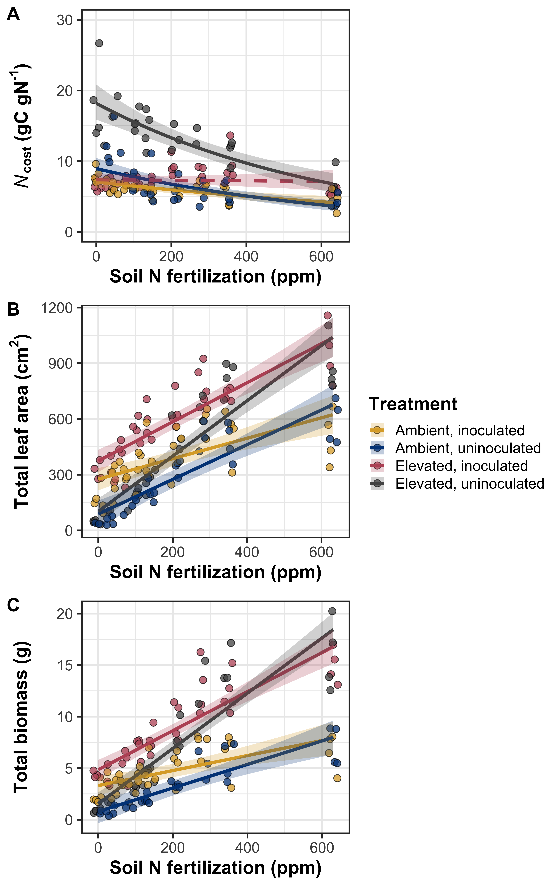

**Figure 1** Effects of nitrogen fertilization, inoculation treatment, and CO2 treatment on structural carbon costs to acquire nitrogen (panel A), total leaf area (panel B), and total biomass (panel C). Soil nitrogen fertilization is represented continuously on the x-axis. Yellow points and trendlines indicate inoculated individuals grown under ambient CO2, blue points and trendlines indicate uninoculated individuals grown under ambient CO2, red points and trendlines indicate inoculated individuals grown under elevated CO2, and grey points indicate uninoculated individuals grown under elevated CO2. Solid trendlines indicate slopes that are different from zero (p<0.05), while dashed trendlines indicate slopes that are not different from zero (p>0.05). Curvilinear trendlines occur as a result of back-transforming models where response variables received either a natural log or square root transformation prior to fitting. Error ribbons represent upper and lower 95% confidence intervals, calculated using the ‘emmeans’ R package (Lenth, 2019).

*Nitrogen fixation*

Increasing nitrogen fertilization generally decreased root nodule biomass (Table 1; Fig. 2A), a pattern that was stronger in inoculated pots (Table 2, inoculation*fertilization interaction; Tukey: p<0.001) and under elevated CO2 concentrations (Table 2, CO2*fertilization interaction; Tukey: p=0.047). Root nodule biomass also generally increased with increasing CO2 concentration and inoculation (Table 2).

Root nodule biomass: root biomass was driven by a three-way interaction between CO2 concentration, inoculation, and soil nitrogen fertilization (Table 2; Fig. 2B). This interaction indicated that increasing fertilization had a similar negative effect on root nodule biomass: root biomass in inoculated pots regardless of CO2 concentration (Tukey: p>0.999), both of which were stronger than the negative effect of increasing fertilization on root nodule biomass: root biomass in uninoculated pots grown under elevated CO2 (Tukey: p<0.001 in both cases). There was no fertilization effect in uninoculated pots grown under ambient CO2 (Tukey: p=0.912). An interaction between inoculation and fertilization revealed that the general negative effect of increasing fertilization was stronger in inoculated pots (Table 1), while an additional interaction between CO2 and fertilization revealed a stronger negative effect of increasing fertilization in pots grown under elevated CO2 (Tukey: p<0.001). We found no individual effect of CO2 concentration (Table 2; Tukey: p=0.106), but a general positive effect of inoculation and a general negative effect of increasing fertilization on root nodule biomasss: root biomass (Tukey: p<0.001 in both cases).

[placeholder for %Ndfa]

**Table 2** Effects of soil nitrogen fertilization, inoculation, and CO2 on the root nodule biomass: root biomass ratio and root nodule biomass*

|  |  |  |  |  |  |  |  |
| --- | --- | --- | --- | --- | --- | --- | --- |
|  |  | **Root nodule biomass** | | | **Root nodule: root biomass** | | |
|  | df | Coefficient | *χ*2 | p-value | Coefficient | *χ*2 | p-value |
| (Intercept) | - | 5.83E-01 | - | - | 5.58E-01 | - | - |
| CO2 | 1 | 7.37E-02 | 19.965 | **<0.001** | -4.27E-02 | 0.587 | 0.444 |
| Inoculation (I) | 1 | -5.74E-01 | 866.896 | **<0.001** | -5.45E-01 | 775.160 | **<0.001** |
| N fertilization (N) | 1 | -5.75E-04 | 99.039 | **<0.001** | -7.57E-04 | 252.088 | **<0.001** |
| CO2*I | 1 | 5.50E-02 | 0.698 | 0.404 | 1.87E-01 | 26.244 | **<0.001** |
| CO2*N | 1 | -8.62E-05 | 3.915 | **0.048** | 7.74E-06 | 5.358 | **0.021** |
| I*N | 1 | 5.82E-04 | 44.514 | **<0.001** | 7.50E-04 | 95.367 | **<0.001** |
| CO2*I*N | 1 | -1.40E-04 | 0.833 | 0.362 | -3.16E-04 | 6.827 | **0.009** |

*Significance determined using Type II Wald χ2 tests (α=0.05). *P*-values less than 0.05 are in bold and p-values between 0.05 and 0.10 are italicized. Key: df=degrees of freedom.

**Figure 2**

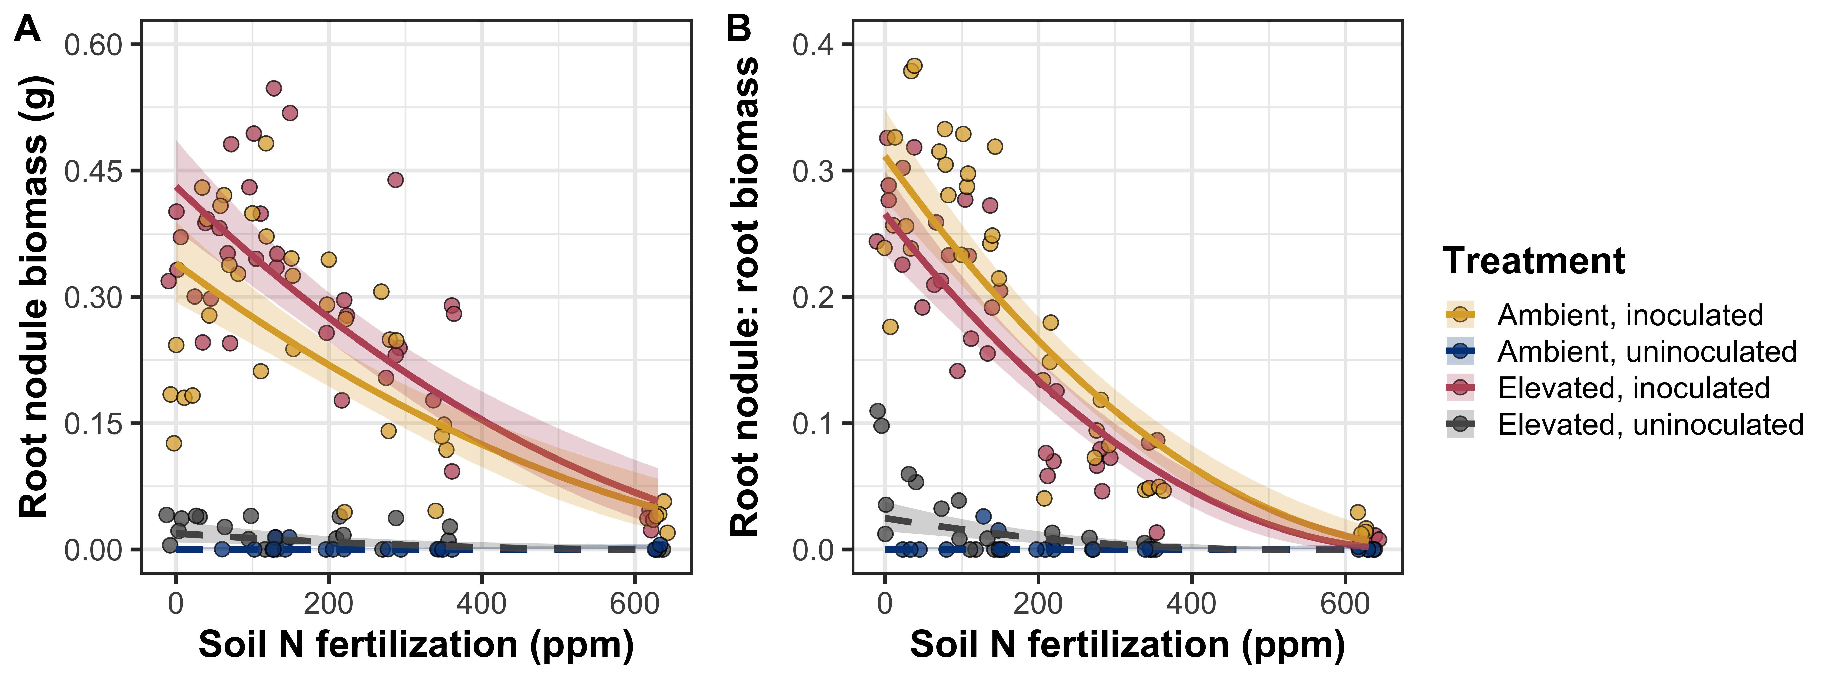

**Figure 2** Effects of nitrogen fertilization, inoculation treatment, and CO2 treatment on root nodule biomass (panel A), the ratio of root nodule biomass to root biomass (panel B), and the percent of leaf nitrogen fixed from the atmosphere (panel C). Soil nitrogen fertilization is represented continuously on the x-axis. Yellow points and trendlines indicate inoculated individuals grown under ambient CO2, blue points and trendlines indicate uninoculated individuals grown under ambient CO2, red points and trendlines indicate inoculated individuals grown under elevated CO2, and grey points indicate uninoculated individuals grown under elevated CO2. Solid trendlines indicate slopes that are different from zero (p<0.05), while dashed trendlines indicate slopes that are not different from zero (p>0.05). Curvilinear trendlines occur as a result of back-transforming models where response variables received either a natural log or square root transformation prior to fitting. Error ribbons represent upper and lower 95% confidence intervals, calculated using the ‘emmeans’ R package (Lenth, 2019).

*Leaf N content*

Increasing nitrogen fertilization generally increased leaf nitrogen content per unit leaf area (Table 3; Fig. 3A) and leaf nitrogen content (Table 3; Fig. 3B); however, these patterns were stronger in uninoculated pots (Table 3, inoculation*fertilization interaction; Tukey: p<0.001 in both cases) and under ambient CO2 (Table 3, CO2*fertilization interaction; TukeyNarea: p=0.010; TukeyNmass: p<0.001). An additional interaction between inoculation and CO2 concentration indicated that the general positive effect of inoculation on *N*area (Table 3) was stronger under elevated CO2 (45% increase vs. 19% increase under ambient CO2; Tukey: p<0.001 in both cases). We also observed a general negative effect of increasing CO2 concentration on *N*area and *N*mass (Table 3).

Increasing nitrogen fertilization also generally increased leaf mass per area (Table 3; Fig. 3C), a pattern that was generally stronger in uninoculated pots (Table 3, inoculation*fertilization interaction; Tukey: p=0.043) and under elevated CO2 (Table 3, CO2*fertilization interaction; Tukey: p<0.001). Increasing CO2 concentration and inoculation each generally increased *M*area (Table 3).

Chlorophyll content per unit leaf area generally increased with increasing fertilization (Table 3; Fig. 3D), a pattern that was generally stronger in uninoculated pots Table 3, inoculation*fertilization interaction; Tukey: p<0.001) and under elevated CO2 (Table 3, CO2*fertilization interaction; Tukey: p=0.022). A marginal three-way interaction between CO2 concentration, inoculation, and nitrogen fertilization, indicating that the general positive effect of increasing fertilization on *Chl*area had a similar positive effect on *Chl*area in inoculated pots regardless of CO2 concentration (Tukey: p=0.980), both of which had stronger positive fertilization effects than uninoculated pots grown under either CO2 concentration (Tukey: p<0.001 in all cases). However, uninoculated pots grown under ambient CO2 had a stronger positive response to increasing fertilization than uninoculated pots grown under elevated CO2 (Tukey: p=0.028). Finally, we observed a general negative effect of increasing CO2 concentration and a positive effect of inoculation on *Chl*area (Table 3).

**Table 3** Effects of soil nitrogen fertilization, inoculation, and CO2 on leaf nitrogen content per unit leaf area, leaf nitrogen content, and leaf mass per area*

|  |  |  |  |  |  |  |  |  |  |  |
| --- | --- | --- | --- | --- | --- | --- | --- | --- | --- | --- |
|  |  | ***N*area** | | | ***N*mass** | | | ***M*areaa** | | |
|  | df | Coefficient | *χ*2 | p-value | Coefficient | *χ*2 | p-value | Coefficient | *χ*2 | p-value |
| (Intercept) | - | 1.72E+00 | - | - | 3.80E-02 | - | - | 3.82E+00 | - | - |
| CO2 | 1 | -3.04E-01 | 151.621 | **<0.001** | -1.40E-02 | 256.837 | **<0.001** | 2.68E-01 | 133.434 | **<0.001** |
| Inoculation (I) | 1 | -6.21E-01 | 92.226 | **<0.001** | -7.51E-03 | 17.799 | **<0.001** | -1.82E-01 | 19.045 | **<0.001** |
| N fertilization (N) | 1 | 1.70E-03 | 328.699 | **<0.001** | 3.79E-05 | 110.108 | **<0.001** | -2.79E-05 | 22.359 | **<0.001** |
| CO2*I | 1 | -2.15E-01 | 4.138 | **0.042** | -3.84E-03 | 2.090 | 0.148 | 4.44E-02 | 0.048 | 0.826 |
| CO2*N | 1 | -6.90E-04 | 7.287 | **0.007** | -3.13E-05 | 24.063 | **<0.001** | 4.12E-04 | 7.191 | **0.007** |
| I*N | 1 | 1.36E-03 | 42.048 | **<0.001** | 1.99E-05 | 11.443 | **0.001** | 3.40E-04 | 4.278 | **0.039** |
| CO2*I*N | 1 | 1.83E-04 | 0.166 | 0.684 | 2.16E-06 | 0.030 | 0.862 | -1.59E-04 | 0.396 | 0.529 |
|  |  |  |  |  |  |  |  |  |  |  |
|  |  | ***Chl*area** | | |  |  |  |  |  |  |
|  | df | Coefficient | *χ*2 | p-value |  |  |  |  |  |  |
| (Intercept) | - | 1.46E-01 | - | - |  |  |  |  |  |  |
| CO2 | 1 | -4.74E-02 | 59.822 | **<0.001** |  |  |  |  |  |  |
| Inoculation (I) | 1 | -1.24E-01 | 157.650 | **<0.001** |  |  |  |  |  |  |
| N fertilization (N) | 1 | 6.94E-05 | 195.862 | **<0.001** |  |  |  |  |  |  |
| CO2*I | 1 | 3.79E-02 | 4.413 | **0.036** |  |  |  |  |  |  |
| CO2*N | 1 | -1.31E-05 | 5.093 | **0.024** |  |  |  |  |  |  |
| I*N | 1 | 2.67E-04 | 85.121 | **<0.001** |  |  |  |  |  |  |
| CO2*I*N | 1 | -8.72E-05 | 3.251 | *0.071* |  |  |  |  |  |  |

*Significance determined using Type II Wald χ2 tests (α=0.05). *P*-values less than 0.05 are in bold and p-values between 0.05 and 0.10 are italicized. Superscripts after trait labels indicate whether models were fit with natural log (a) or square root (b) transformed response variables. Key: df=degrees of freedom, *N*area=leaf nitrogen content per unit leaf area, *N*mass=leaf nitrogen content, *M*area=leaf mass per unit leaf area.

**Figure 3**

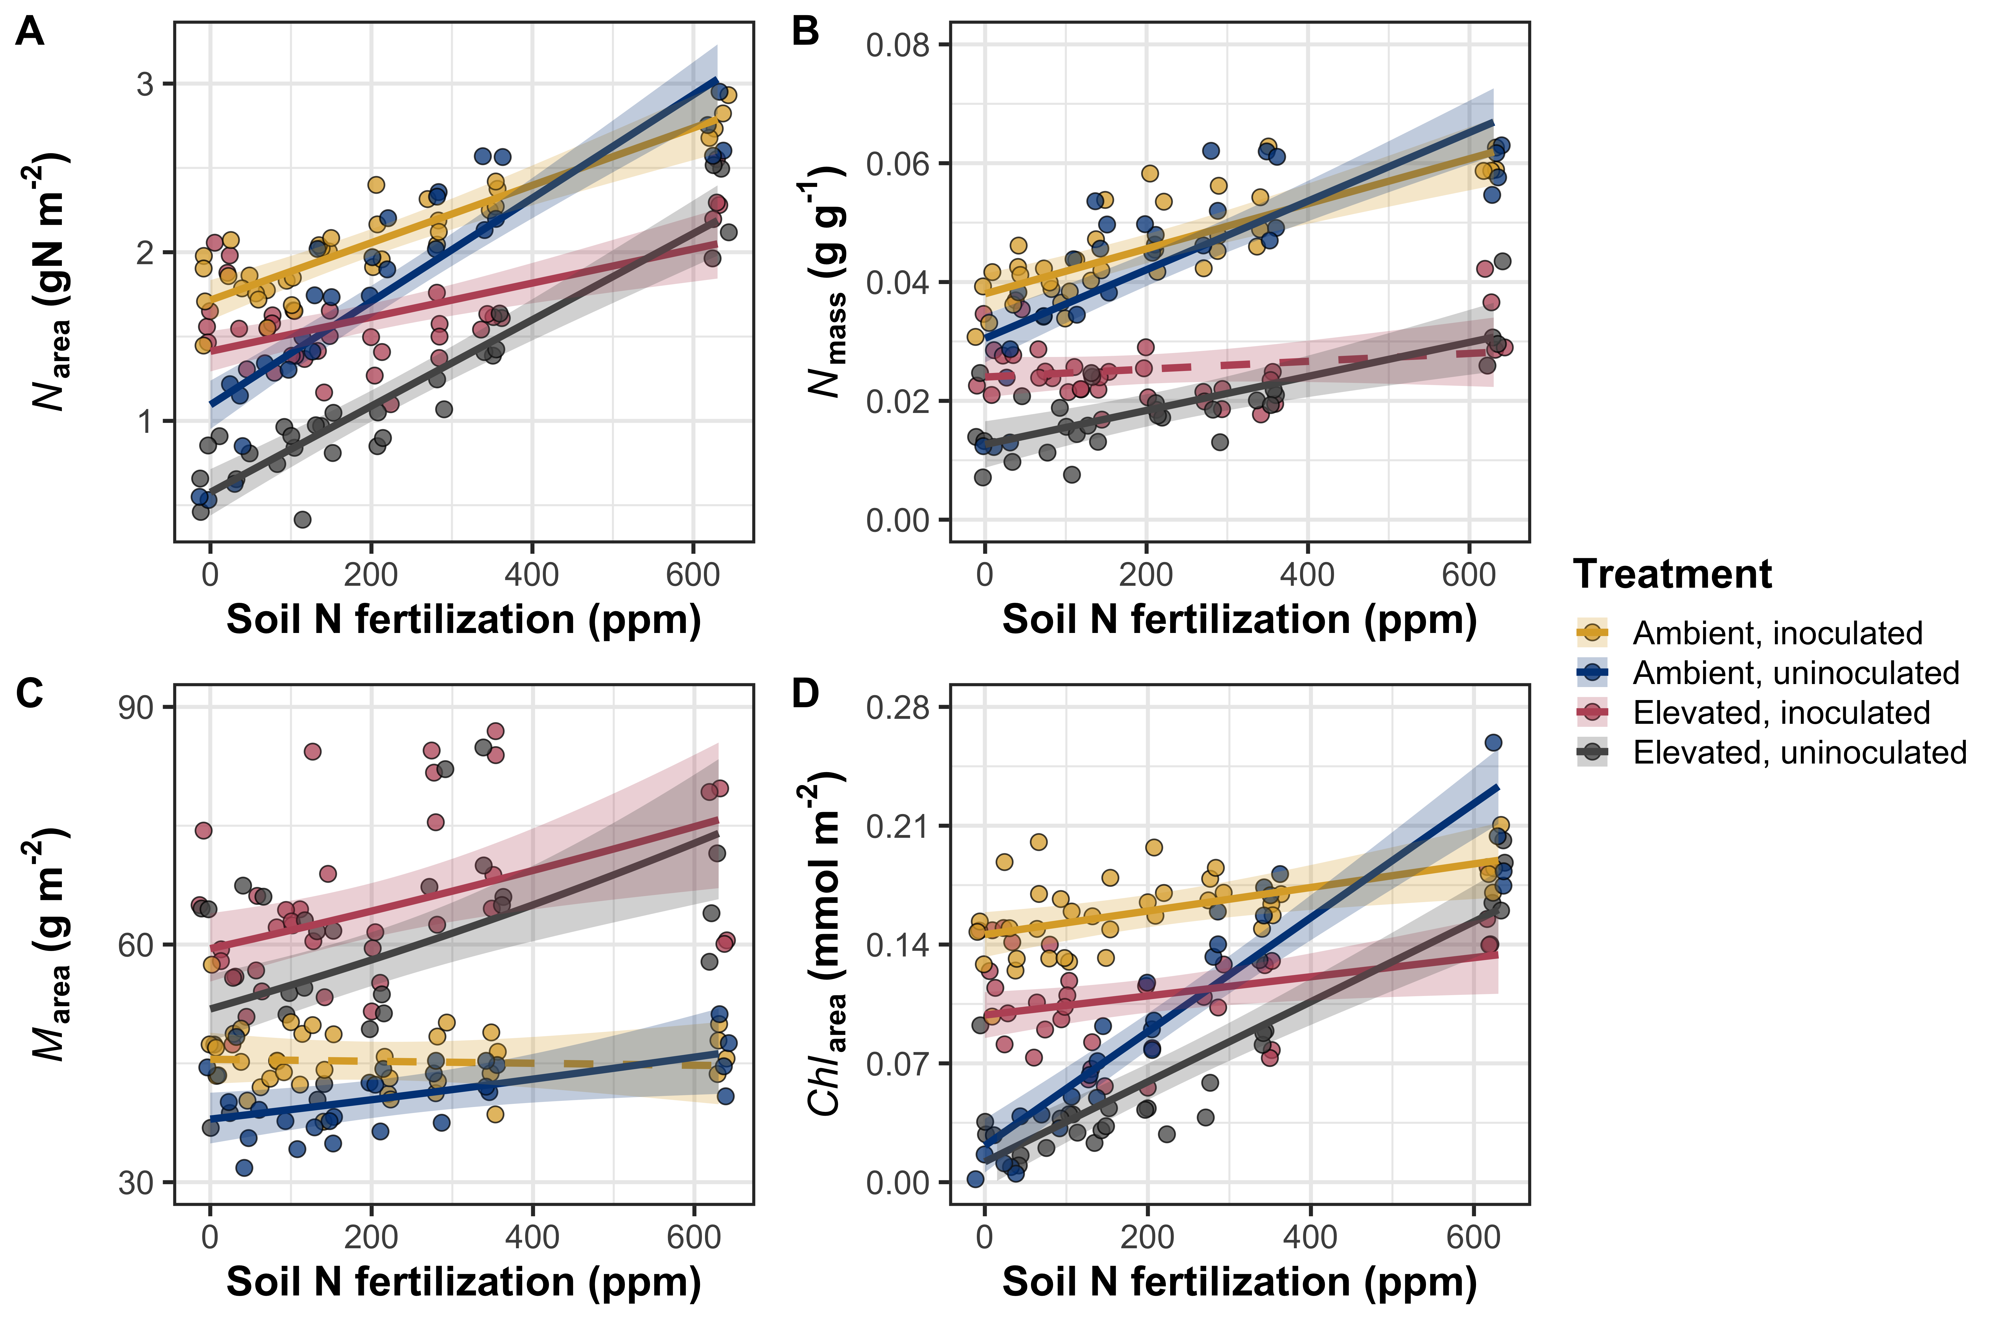

**Figure 3** Effects of nitrogen fertilization, inoculation treatment, and CO2 treatment on leaf nitrogen per unit leaf area (panel A), leaf nitrogen content (panel B), leaf mass per unit leaf area (panel C), and chlorophyll content per unit leaf area (panel D). Soil nitrogen fertilization is represented continuously on the x-axis. Yellow points and trendlines indicate inoculated individuals grown under ambient CO2, blue points and trendlines indicate uninoculated individuals grown under ambient CO2, red points and trendlines indicate inoculated individuals grown under elevated CO2, and grey points indicate uninoculated individuals grown under elevated CO2. Solid trendlines indicate slopes that are different from zero (p<0.05), while dashed trendlines indicate slopes that are not different from zero (p>0.05). Error ribbons represent upper and lower 95% confidence intervals, calculated using the ‘emmeans’ R package (Lenth, 2019).

*Gas exchange*

Increasing nitrogen fertilization generally increased *V*cmax25 and *J*max25 (Table 4; Figs. 4A-B), although this effect was only apparent in uninoculated pots (Table 4, inoculation*fertilization interaction; Tukey: p<0.001 in both cases). There was no effect of fertilization on either process rate in inoculated pots (Tukeyvcmax: p=0.452; Tukeyjmax: p=0.177). *V*cmax25 and *J*max25 each generally increased with increasing CO2 concentration and inoculation (Table 4).

Increasing nitrogen fertilization also generally decreased *J*max25: *V*cmax25 (Table 4; Fig. 4C), a pattern that was stronger in uninoculated pots (Table 4, inoculation*fertilization interaction, Tukey: p=0.002) and marginally stronger under ambient CO2 (Table 4, marginal CO2*fertilization interaction, Tukey: p=0.071). Increasing CO2 concentration generally increased and inoculation generally decreased *J*max25: *V*cmax25 (Table 4).

While there was no individual effect of nitrogen fertilization on stomatal conductance (Table 4), an interaction between fertilization and inoculation indicated a positive effect of increasing fertilization on *g*sw in uninoculated pots (Tukey: p=0.002) and a negative effect in inoculated pots (Tukey: p=0.020). Increasing CO2 concentration generally decreased *g*sw and inoculation generally increased *g*sw (Table 4).

Increasing fertilization generally decreased leaf *C*i: *C*a and was marginally higher in inoculated pots (Table 4).

Increasing fertilization generally increased stomatal limitation (Table 4). Inoculation also generally increased stomatal limitation (Table 4), a pattern that was only apparent under ambient CO2 (Table 4, marginal CO2*inoculation interaction; Tukey: p=0.016).

**Table 4** Effects of soil nitrogen fertilization, inoculation, and CO2 on leaf gas exchange*

|  |  |  |  |  |  |  |  |  |  |  |
| --- | --- | --- | --- | --- | --- | --- | --- | --- | --- | --- |
|  |  | ***V*cmax25** | | | ***J*cmax25** | | | ***J*cmax25: *V*cmax25** | | |
|  | df | Coefficient | *χ*2 | p-value | Coefficient | *χ*2 | p-value | Coefficient | *χ*2 | p-value |
| (Intercept) | - | 1.02E+02 | - | - | 1.79E+02 | - | - | 1.74E+00 | - | - |
| CO2 | 1 | -1.17E+01 | 18.930 | **<0.001** | -8.31E+00 | 7.077 | **0.008** | 1.46E-01 | 89.681 | **<0.001** |
| Inoculation (I) | 1 | -5.88E+01 | 116.844 | **<0.001** | -9.63E+01 | 102.643 | **<0.001** | 1.79E-01 | 30.798 | **<0.001** |
| N fertilization (N) | 1 | -3.73E-03 | 43.110 | **<0.001** | -2.14E-02 | 30.354 | **<0.001** | -1.35E-04 | 30.333 | **<0.001** |
| CO2*I | 1 | 2.45E+00 | 0.291 | 0.590 | -5.22E+00 | 1.347 | 0.246 | -8.04E-02 | 2.548 | 0.110 |
| CO2*N | 1 | -8.61E-03 | 1.875 | 0.171 | -8.94E-03 | 0.767 | 0.381 | 6.95E-05 | 3.168 | *0.075* |
| I*N | 1 | 1.36E-01 | 64.411 | **<0.001** | 2.30E-01 | 61.357 | **<0.001** | -3.26E-04 | 10.311 | **0.001** |
| CO2*I*N | 1 | -2.59E-02 | 0.716 | 0.397 | -3.17E-02 | 0.335 | 0.563 | 1.49E-04 | 0.917 | 0.338 |
|  |  |  |  |  |  |  |  |  |  |  |
|  |  | ***g*sw** | | | ***C*i:*C*a** | | | **Stomatal limitation** | | |
|  | df | Coefficient | *χ*2 | p-value | Coefficient | *χ*2 | p-value | Coefficient | *χ*2 | p-value |
| (Intercept) | - | 3.25E-01 | - | - | 6.96E-01 | - | - | 2.91E-01 | - | - |
| CO2 | 1 | 4.62E-03 | 10.835 | **0.001** | 2.28E-02 | 0.622 | 0.430 | -4.00E-02 | 0.878 | 0.349 |
| Inoculation (I) | 1 | -1.30E-01 | 27.743 | **<0.001** | 4.56E-02 | 2.898 | 0.089 | -7.87E-02 | 5.317 | **0.021** |
| N fertilization (N) | 1 | -5.99E-05 | 0.217 | 0.642 | -9.89E-05 | 28.083 | **<0.001** | 9.34E-05 | 34.432 | **<0.001** |
| CO2*I | 1 | -7.64E-02 | 2.553 | 0.110 | -3.76E-02 | 1.067 | 0.302 | 7.46E-02 | 3.793 | *0.051* |
| CO2*N | 1 | -1.74E-04 | 2.040 | 0.153 | -2.27E-05 | 0.120 | 0.729 | 4.87E-05 | 0.324 | 0.569 |
| I*N | 1 | 3.10E-04 | 16.315 | **<0.001** | -9.12E-05 | 0.942 | 0.332 | 1.67E-04 | 2.437 | 0.118 |
| CO2*I*N | 1 | 9.99E-05 | 0.313 | 0.576 | 8.45E-05 | 0.694 | 0.405 | -1.66E-04 | 2.362 | 0.124 |

*Significance determined using Type II Wald χ2 tests (α=0.05). *P*-values less than 0.05 are in bold and p-values between 0.05 and 0.10 are italicized. Superscripts after trait labels indicate whether models were fit with natural log (a) or square root (b) transformed response variables. Key: df=degrees of freedom, *V*cmax25=maximum rate of Rubisco carboxylation at 25°C; *J*max25=maximum rate of RuBP regeneration at 25°C, *J*max25:*V*cmax25=ratio of *J*max25 to *V*cmax25; *g*sw= stomatal conductance; *C*i:*C*a=ratio of intercellular CO2 to extracellular CO2

**Figure 4**

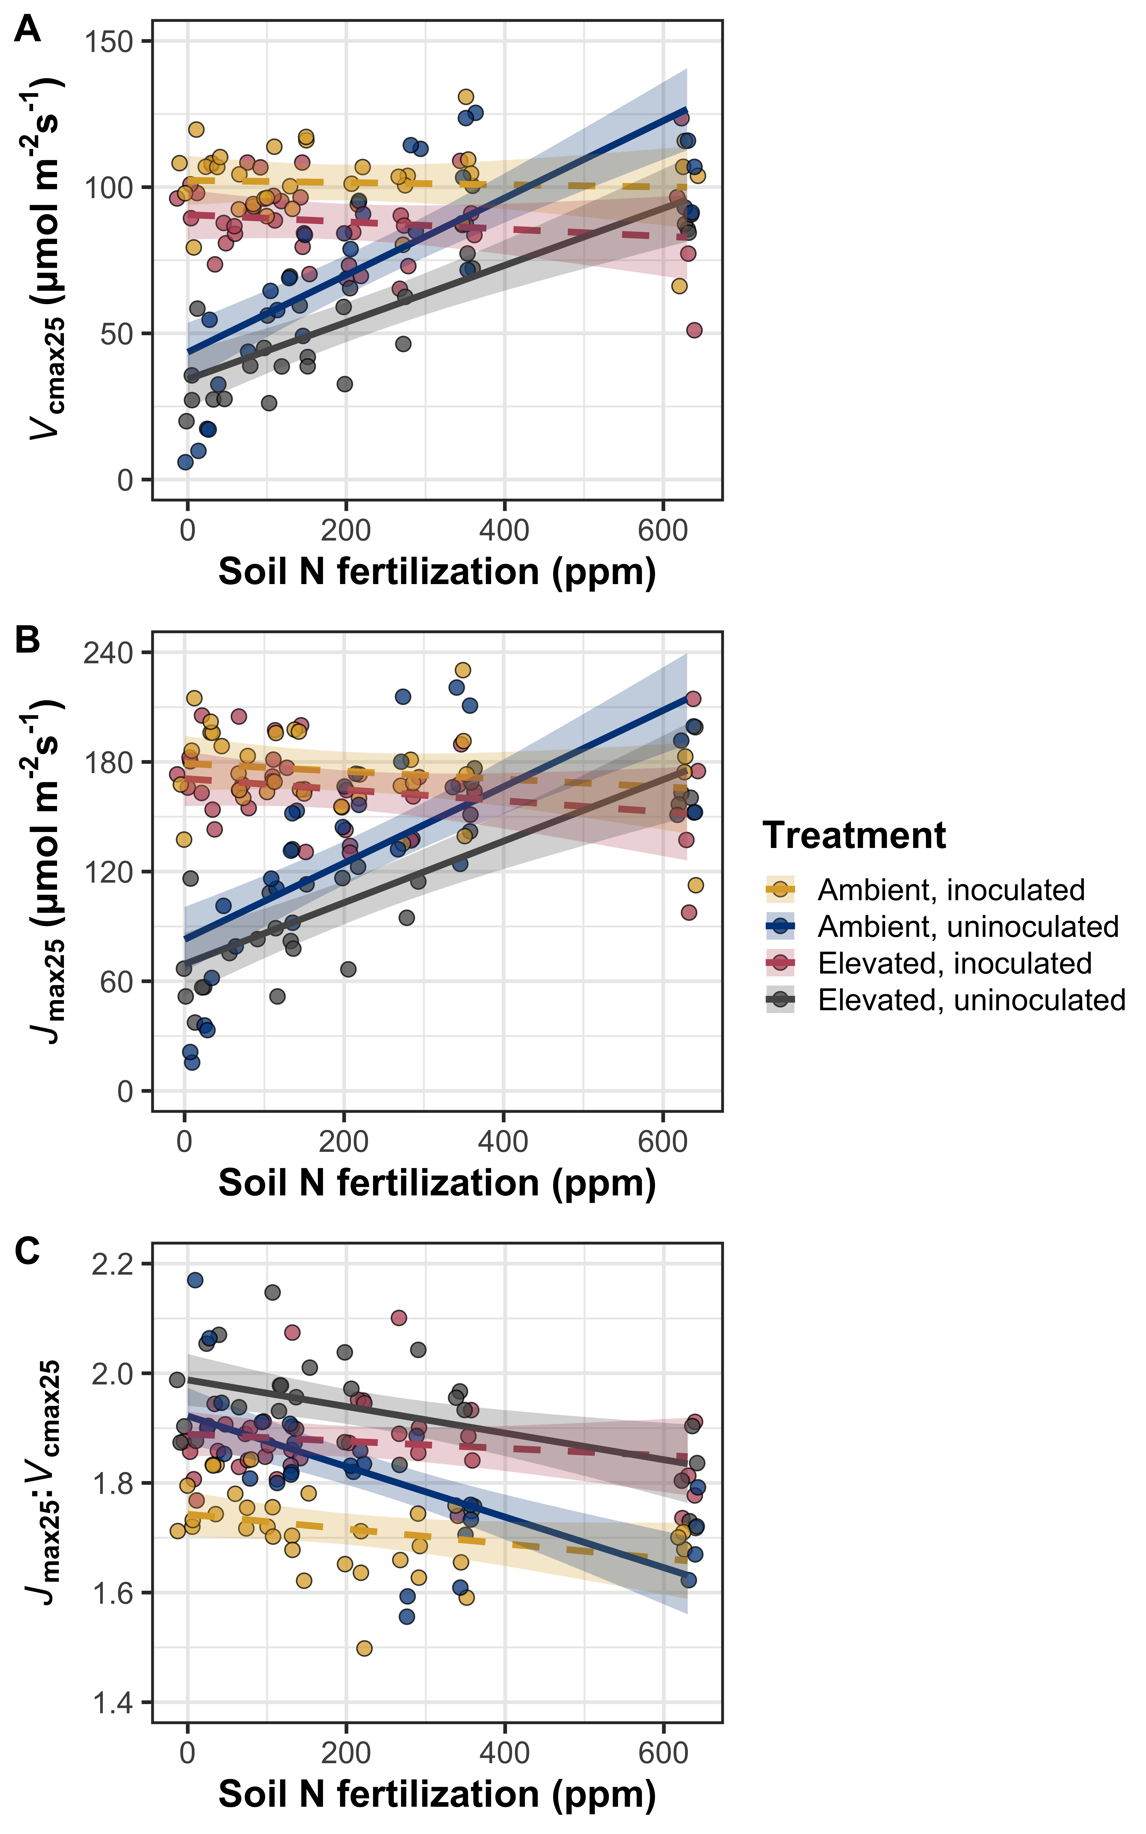**ƒ**

**Figure 4** Effects of soil nitrogen fertilization, inoculation treatment, and CO2 treatment on the maximum rate of Rubisco carboxylation (panel A), the maximum rate of RuBP regeneration (panel B), and the ratio of the maximum rate of RuBP regeneration to the maximum rate of Rubisco carboxylation (panel C).Soil nitrogen fertilization is represented continuously on the x-axis. Yellow points and trendlines indicate inoculated individuals grown under ambient CO2, blue points and trendlines indicate uninoculated individuals grown under ambient CO2, red points and trendlines indicate inoculated individuals grown under elevated CO2, and grey points indicate uninoculated individuals grown under elevated CO2. Solid trendlines indicate slopes that are different from zero (p<0.05), while dashed trendlines indicate slopes that are not different from zero (p>0.05). Error ribbons represent upper and lower 95% confidence intervals, calculated using the ‘emmeans’ R package (Lenth, 2019).

*Leaf nitrogen allocation*

Increasing nitrogen fertilization generally decreased *ρ*rubisco and *ρ*bioe (Table 5; Figs. 5A-B), a pattern that was only observed in inoculated pots (Table 5, inoculation*fertilization interaction; Tukey: p<0.001 in both cases). Increasing CO2 and inoculation each generally increased *ρ*rubisco and *ρ*bioe (Table 5).

The fraction of leaf nitrogen allocated to light harvesting was driven by a three-way interaction between CO2 concentration, inoculation, and nitrogen fertilization (Table 5; Fig. 5C). This interaction indicated that increasing fertilization increased *ρ*light in uninoculated pots regardless of CO2 concentration (Tukey p<0.001 in both cases); however, decreased *ρ*light in inoculated pots grown under ambient CO2 (Tukey: p=0.007) and had no effect on inoculated pots grown under elevated CO2 (Tukey: p=0.893). An interaction between inoculation and fertilization indicated that increasing fertilization increased *ρ*light in uninoculated pots (Tukey: p<0.001) and marginally decreased *ρ*light in inoculated pots (Tukey: p=0.052). Individually, increasing CO2 had no effect on *ρ*light, while inoculation generally increased and increasing fertilization generally decreased *ρ*light (Table 5).

Increasing nitrogen fertilization generally decreased *ρ*photo (Table 6; Fig. 6D), a pattern that was only observed in inoculated pots (Table 6; inoculation*fertilization interaction; Tukey: p<0.001). There was no effect of fertilization on *ρ*photo in uninoculated pots (Tukey: p=0.269). A marginal three-way interaction between CO2 concentration, inoculation, and fertilization indicated that the negative effect of increasing fertilization on *ρ*photo in inoculated pots was similar between CO2 concentrations (Tukey: p=0.986). However, the null effect of fertilization on *ρ*photo in uninoculated pots was only apparent under elevated CO2 (Tukey: p=0.558), as there was a slight stimulation in *ρ*photo in uninoculated pots grown under ambient CO2 (Tukey: p=0.034; Fig. 6D). Individually, increasing CO2 concentration and inoculation each generally increased *ρ*photo (Table 6).

An apparent three-way interaction between CO2 concentration, inoculation, and nitrogen fertilization (Table 6) indicated that increasing fertilization decreased decreased *ρ*structure in uninoculated pots similarly between CO2 concentrations (Tukey: p=0.887). However, inoculated pots diverged in the response of *ρ*structure to fertilization, where inoculated pots grown under ambient CO2 exhibited a reduction in *ρ*structure with increasing fertilization (Tukey: p<0.001) that was similar to uninoculated pots grown under either CO2 concentration (Tukeyamb: p=0.999; Tukeyelv: p=0.922), while inoculated pots grown under elevated CO2 exhibited no effect of fertilization on *ρ*structure (Tukey: p=0.812). This resulted in a marginally stronger reduction in *ρ*structure with increasing fertilization in inoculated pots grown under ambient CO2 (Tukey: p=0.052). Increasing fertilization also generally decreased *ρ*structure (Table 6; Fig. 6E), a pattern that was slightly stronger in uninoculated pots (Table 6, inoculation*fertilization interaction; Tukey: p=0.041). Inoculation generally decreased *ρ*structure (Table 6); however, this pattern was only apparent in puts grown under ambient CO2 (Table 6; CO2*inoculation interaction; Tukey: p<0.001). Individually, increasing CO2 concentration generally increased *ρ*structure (Table 6).

**Table 5** Effects of soil nitrogen fertilization, inoculation, and CO2 on the fraction of leaf nitrogen allocated to Rubisco, bioenergetics, light harvesting proteins, photosynthesis, and structure*

|  |  |  |  |  |  |  |  |  |  |  |
| --- | --- | --- | --- | --- | --- | --- | --- | --- | --- | --- |
|  |  | ***ρ*rubisco** | | | ***ρ*bioe** | | | ***ρ*light** | | |
|  | df | Coefficient | *χ*2 | p-value | Coefficient | *χ*2 | p-value | Coefficient | *χ*2 | p-value |
| (Intercept) | - | 4.54E-01 | - | - | 8.06E-02 | - | - | 2.88E-02 | - | - |
| CO2 | 1 | 3.71E-02 | 16.381 | **<0.001** | 1.33E-02 | 46.492 | **<0.001** | -3.44E-03 | 0.113 | 0.737 |
| Inoculation (I) | 1 | -1.84E-01 | 30.202 | **<0.001** | -2.80E-02 | 18.802 | **<0.001** | -2.03E-02 | 148.463 | **<0.001** |
| N fertilization (N) | 1 | -2.93E-04 | 14.771 | **<0.001** | -5.65E-05 | 24.414 | **<0.001** | -1.14E-05 | 21.175 | **<0.001** |
| CO2*I | 1 | 8.40E-02 | 2.288 | 0.130 | 1.29E-02 | 1.150 | 0.284 | 5.83E-03 | 1.154 | 0.283 |
| CO2*N | 1 | 2.17E-05 | 1.250 | 0.264 | 4.71E-06 | 0.915 | 0.339 | 1.08E-05 | 0.183 | 0.669 |
| I*N | 1 | 4.31E-04 | 23.378 | **<0.001** | 6.88E-05 | 16.692 | **<0.001** | 4.36E-05 | 60.343 | **<0.001** |
| CO2*I*N | 1 | -2.07E-04 | 2.348 | 0.125 | -3.56E-05 | 2.054 | 0.152 | -1.88E-05 | 4.467 | **0.035** |
|  |  |  |  |  |  |  |  |  |  |  |
|  |  | ***ρ*photo** | | | ***ρ*structurea** | | |  |  |  |
|  | df | Coefficient | *χ*2 | p-value | Coefficient | *χ*2 | p-value |  |  |  |
| (Intercept) | - | 5.63E-01 | - | - | -3.19E+00 | - | - |  |  |  |
| CO2 | 1 | 4.72E-02 | 18.701 | **<0.001** | 5.81E-01 | 225.944 | **<0.001** |  |  |  |
| Inoculation (I) | 1 | -2.32E-01 | 32.931 | **<0.001** | -5.16E-02 | 7.442 | **0.006** |  |  |  |
| N fertilization (N) | 1 | -3.61E-04 | 13.776 | **<0.001** | -8.02E-04 | 36.537 | **<0.001** |  |  |  |
| CO2*I | 1 | 1.07E-01 | 2.371 | 0.124 | 5.06E-01 | 12.523 | **<0.001** |  |  |  |
| CO2*N | 1 | 3.91E-05 | 1.187 | 0.276 | 7.52E-04 | 2.135 | 0.144 |  |  |  |
| I*N | 1 | 5.43E-04 | 25.186 | **<0.001** | 4.46E-05 | 4.531 | **0.033** |  |  |  |
| CO2*I*N | 1 | -2.70E-04 | 2.769 | *0.096* | -9.83E-04 | 5.275 | **0.022** |  |  |  |

*Significance determined using Type II Wald χ2 tests (α=0.05). *P*-values less than 0.05 are in bold and p-values between 0.05 and 0.10 are italicized. Superscripts after trait labels indicate whether models were fit with natural log (a) or square root (b) transformed response variables. Key: df=degrees of freedom, *ρ*rubisco= proportion of leaf N allocated to photosynthesis; *ρ*bioe= proportion of leaf N allocated to bioenergetics, *ρ*light=proportion of leaf N allocated to light harvesting proteins; *ρ*photo=proportion of leaf N allocated to photosynthesis; *ρ*structure=proportion of leaf N allocated to cell wall structural tissue

**Figure 5**



**Figure 5** Effects of soil nitrogen fertilization, inoculation treatment, and CO2 treatment on the fraction of leaf nitrogen allocated to Rubisco (panel A), bioenergetics (panel B), light harvesting proteins (panel C), photosynthesis (panel D), and structure (panel E). Soil nitrogen fertilization is represented continuously on the x-axis. Yellow points and trendlines indicate inoculated individuals grown under ambient CO2, blue points and trendlines indicate uninoculated individuals grown under ambient CO2, red points and trendlines indicate inoculated individuals grown under elevated CO2, and grey points indicate uninoculated individuals grown under elevated CO2. Solid trendlines indicate slopes that are different from zero (p<0.05), while dashed trendlines indicate slopes that are not different from zero (p>0.05). Curvilinear trendlines occur as a result of back-transforming models where response variables received either a natural log or square root transformation prior to fitting. Error ribbons represent upper and lower 95% confidence intervals, calculated using the ‘emmeans’ R package (Lenth, 2019)

*Tradeoffs between nitrogen and water use*

Increasing nitrogen fertilization generally decreased PNUE (Table 6; Fig. 6A); however, this pattern was only observed in inoculated pots (Table 6, inoculation*fertilization interaction; Tukey: p<0.001). Increasing CO2 concentrations and inoculation each generally increased PNUE (Table 6).

Increasing nitrogen fertilization generally increased intrinsic water use efficiency, with no apparent individual or interactive effect of CO2 and inoculation (Table 6; Fig. 6B).

Increasing nitrogen fertilization generally increased *N*area:*g*sw (Table 6; Fig. 6C), a pattern that was only observed in inoculated pots (Table 6, inoculation*fertilization interaction; Tukey: p<0.001). Increasing CO2 concentration and inoculation each generally increased *N*area:*g*sw (Table 6).

Increasing nitrogen fertilization generally increased *V*cmax:*g*sw (Table 6; Fig. 6D). A weak marginal interaction between CO2 concentration and inoculation (Table 6) indicated that inoculation resulted in an 11% nonsignificant stimulation in *V*cmax:*g*sw under ambient CO2 (Tukey: p=0.496), coupled with a 7% nonsignificant reduction in *V*cmax:*g*sw under elevated CO2 (Tukey: p=0.797). There was no individual effect of CO2 concentration or inoculation on *V*cmax:*g*sw (Table 6).

**Table 6** Effects of soil nitrogen fertilization, inoculation, and CO2 on tradeoffs between nitrogen and water usage

|  |  |  |  |  |  |  |  |  |  |  |
| --- | --- | --- | --- | --- | --- | --- | --- | --- | --- | --- |
|  |  | ***PNUE*** | | | ***iWUE*** | | | ***N*area:*g*swa** | | |
|  | df | Coefficient | *χ*2 | p-value | Coefficient | *χ*2 | p-value | Coefficient | *χ*2 | p-value |
| (Intercept) | - | 1.19E+01 | - | - | 6.46E+01 | - | - | 1.66E+00 | - | - |
| CO2 | 1 | 1.64E+00 | 13.682 | **<0.001** | -4.75E+00 | 0.013 | 0.908 | -1.98E-01 | 4.040 | **0.044** |
| Inoculation (I) | 1 | -4.15E+00 | 23.931 | **<0.001** | -7.04E+00 | 0.390 | 0.532 | 4.30E-01 | 5.365 | **0.021** |
| N fertilization (N) | 1 | -8.29E-03 | 22.581 | **<0.001** | 2.43E-02 | 20.549 | <**0.001** | 1.25E-03 | 21.373 | **<0.001** |
| CO2*I | 1 | 6.87E-01 | 0.036 | 0.849 | 1.01E+01 | 1.211 | 0.271 | -8.19E-02 | 0.033 | 0.855 |
| CO2*N | 1 | -1.08E-03 | 1.157 | 0.282 | 1.00E-02 | <0.001 | 0.992 | 2.47E-04 | 0.815 | 0.367 |
| I*N | 1 | 9.71E-03 | 16.719 | **<0.001** | 1.25E-02 | 0.019 | 0.891 | -1.09E-03 | 5.764 | **0.016** |
| CO2*I*N | 1 | -2.46E-03 | 0.352 | 0.553 | -2.14E-02 | 0.640 | 0.424 | 2.48E-04 | 0.095 | 0.758 |
|  |  |  |  |  |  |  |  |  |  |  |
|  |  | ***V*cmax25:*g*swa** | | |  |  |  |  |  |  |
|  |  | Coefficient | *χ*2 | p-value |  |  |  |  |  |  |
| (Intercept) | - | 5.72E+00 | - | - |  |  |  |  |  |  |
| CO2 | 1 | -1.09E-01 | 0.086 | 0.770 |  |  |  |  |  |  |
| Inoculation (I) | 1 | -1.80E-01 | 0.099 | 0.753 |  |  |  |  |  |  |
| N fertilization (N) | 1 | 4.97E-04 | 20.316 | **<0.001** |  |  |  |  |  |  |
| CO2*I | 1 | 3.22E-01 | 2.714 | *0.099* |  |  |  |  |  |  |
| CO2*N | 1 | 2.77E-04 | 0.030 | 0.862 |  |  |  |  |  |  |
| I*N | 1 | 3.47E-04 | <0.001 | 0.986 |  |  |  |  |  |  |
| CO2*I*N | 1 | -6.87E-04 | 1.468 | 0.226 |  |  |  |  |  |  |

*Significance determined using Type II Wald χ2 tests (α=0.05). *P*-values less than 0.05 are in bold and p-values between 0.05 and 0.10 are italicized. Superscripts after trait labels indicate whether models were fit with natural log (a) or square root (b) transformed response variables. Key: df=degrees of freedom, PNUE=photosynthetic nitrogen-use efficiency, iWUE=intrinsic water-use efficiency, *N*area:*g*sw=ratio of leaf nitrogen per unit leaf area to stomatal conductance, *V*cmax25:*g*sw=maximum Rubisco carboxylation rate to stomatal conductance

**Figure 6**

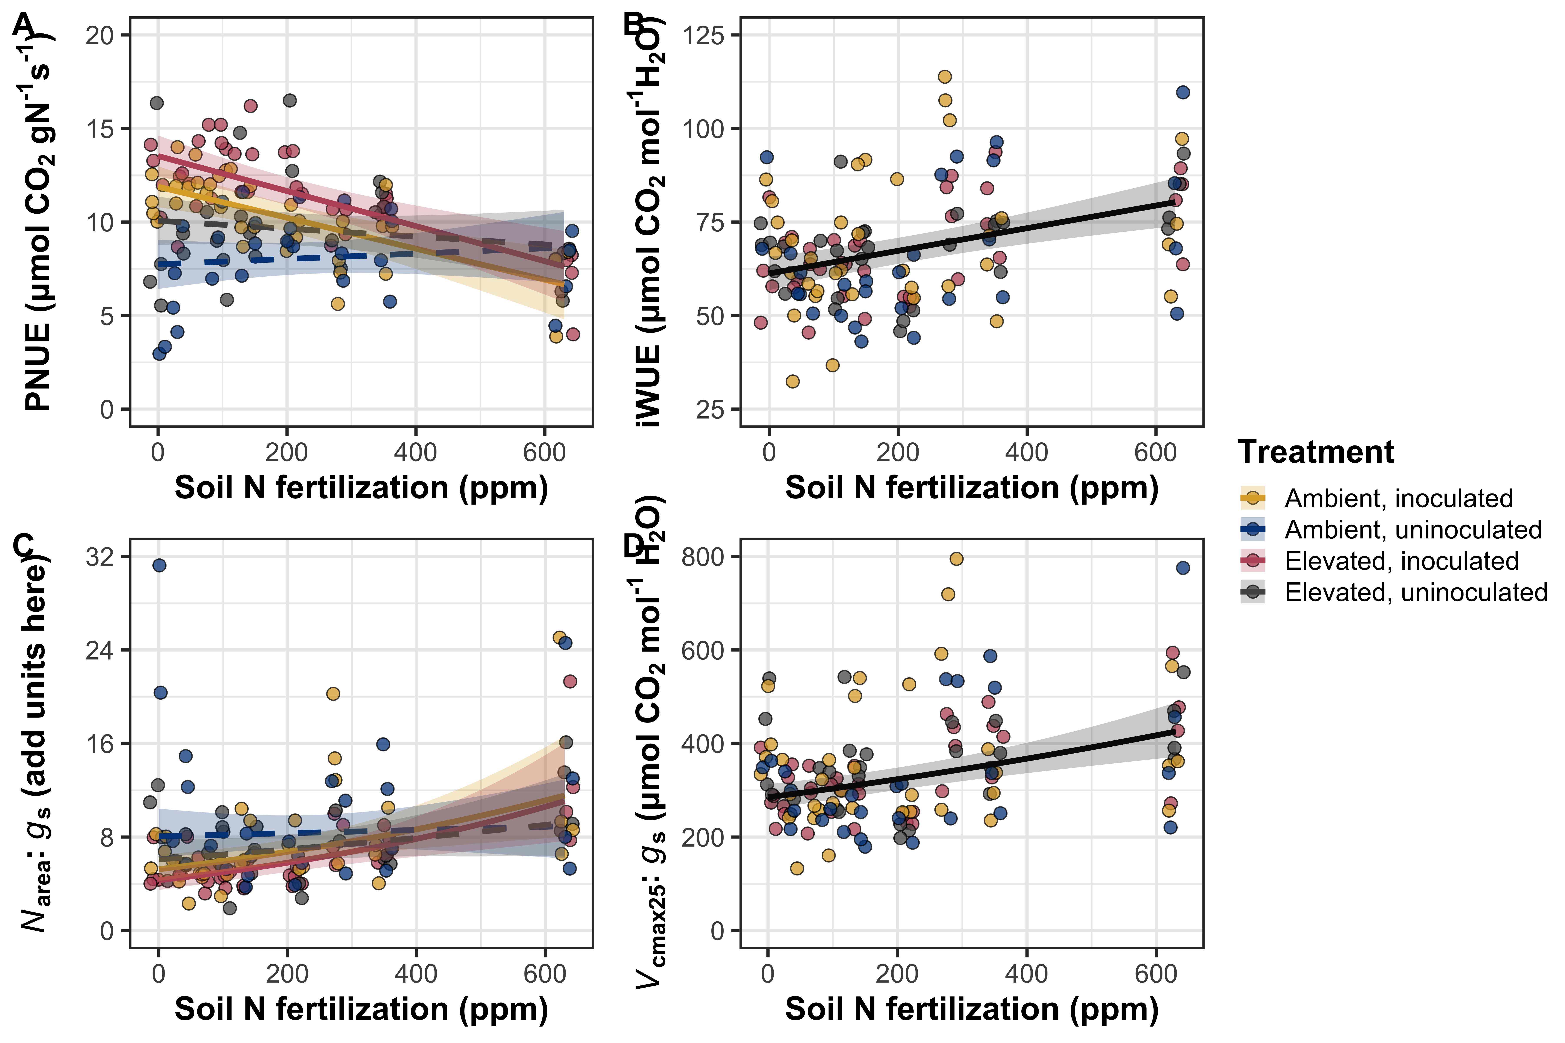

**Figure 6** Effects of soil nitrogen fertilization, inoculation treatment, and CO2 treatment on photosynthetic nitrogen-use efficiency (panel A), intrinsic water use efficiency (panel B), the ratio of leaf nitrogen content per stomatal conductance (panel C), and the ratio of the maximum rate of Rubisco carboxylation per stomatal conductance (panel D). Soil nitrogen fertilization is represented continuously on the x-axis. Yellow points and trendlines indicate inoculated individuals grown under ambient CO2, blue points and trendlines indicate uninoculated individuals grown under ambient CO2, red points and trendlines indicate inoculated individuals grown under elevated CO2, and grey points indicate uninoculated individuals grown under elevated CO2. Solid trendlines indicate slopes that are different from zero (p<0.05), while dashed trendlines indicate slopes that are not different from zero (p>0.05). Curvilinear trendlines occur as a result of back-transforming models where response variables received either a natural log or square root transformation prior to fitting. Error ribbons represent upper and lower 95% confidence intervals, calculated using the ‘emmeans’ R package (Lenth, 2019)

**Discussion**

**References**

Andrews, M., James, E. K., Sprent, J. I., Boddey, R. M., Gross, E., & dos Reis, F. B. (2011). Nitrogen fixation in legumes and actinorhizal plants in natural ecosystems: Values obtained using 15N natural abundance. *Plant Ecology and Diversity*, *4*(2–3), 117–130. https://doi.org/10.1080/17550874.2011.644343

Barnes, J. D., Balaguer, L., Manrique, E., Elvira, S., & Davison, A. W. (1992). A reappraisal of the use of DMSO for the extraction and determination of chlorophylls a and b in lichens and higher plants. *Environmental and Experimental Botany*, *32*(2), 85–100. https://doi.org/10.1016/0098-8472(92)90034-Y

Bates, D., Mächler, M., Bolker, B., & Walker, S. (2015). Fitting linear mixed-effects models using lme4. *Journal of Statistical Software*, *67*(1), 1–48. https://doi.org/10.18637/jss.v067.i01

Bernacchi, C. J., Singsaas, E. L., Pimentel, C., Portis, A. R., & Long, S. P. (2001). Improved temperature response functions for models of Rubisco-limited photosynthesis. *Plant, Cell and Environment*, *24*(2), 253–259. https://doi.org/10.1046/j.1365-3040.2001.00668.x

Cernusak, L. A., Ubierna, N., Winter, K., Holtum, J. A. M., Marshall, J. D., & Farquhar, G. D. (2013). Environmental and physiological determinants of carbon isotope discrimination in terrestrial plants. *New Phytologist*, *200*(4), 950–965. https://doi.org/10.1111/nph.12423

Dovrat, G., Bakhshian, H., Masci, T., & Sheffer, E. (2020). The nitrogen economic spectrum of legume stoichiometry and fixation strategy. *New Phytologist*, *227*(2), 365–375. https://doi.org/10.1111/nph.16543

Dovrat, G., Masci, T., Bakhshian, H., Mayzlish Gati, E., Golan, S., & Sheffer, E. (2018). Drought-adapted plants dramatically downregulate dinitrogen fixation: Evidences from Mediterranean legume shrubs. *Journal of Ecology*, *106*(4), 1534–1544. https://doi.org/10.1111/1365-2745.12940

Duursma, R. (2015). Plantecophys - An R package for analyzing and modelling leaf gas exchange data. *PLos ONE*, *10*(11), e0143346. https://doi.org/10.1371/journal.pone.0143346>

Evans, J. R., & Seemann, J. R. (1989). The allocation of protein nitrogen in the photosynthetic apparatus: costs, consequences, and control. *Photosynthesis*, *8*, 183–205.

Farquhar, G. D., Ehleringer, J. R., & Hubick, K. T. (1989). Carbon isotope discrimination and photosynthesis. *Annual Review of Plant Physiology and Plant Molecular Biology*, *40*(1), 503–537. https://doi.org/10.1146/annurev.pp.40.060189.002443

Farquhar, G. D., & Sharkey, T. D. (1982). Stomatal conductance and photosynthesis. *Annual Review of Plant Physiology*, *33*(1), 317–345. https://doi.org/10.1146/annurev.pp.33.060182.001533

Farquhar, G. D., von Caemmerer, S., & Berry, J. A. (1980). A biochemical model of photosynthetic CO*2* assimilation in leaves of C3 species. *Planta*, *149*(1), 78–90. https://doi.org/10.1007/BF00386231

Fox, J., & Weisberg, S. (2019). *An R companion to applied regression* (Third edit). Retrieved from https://socialsciences.mcmaster.ca/jfox/Books/Companion/

Hoagland, D. R., & Arnon, D. I. (1950). The water-culture method for growing plants without soil. *California Agricultural Experiment Station: 347*, *347*(2), 1–32.

Katabuchi, M. (2015). LeafArea: An R package for rapid digital analysis of leaf area. *Ecological Research*, *30*(6), 1073–1077.

Kenward, M. G., & Roger, J. H. (1997). Small sample inference for fixed effects from restricted maximum likelihood. *Biometrics*, *53*(3), 983. https://doi.org/10.2307/2533558

Lenth, R. (2019). *emmeans: estimated marginal means, aka least-squares means*.

Medlyn, B. E., Dreyer, E., Ellsworth, D. S., Forstreuter, M., Harley, P. C., Kirschbaum, M. U. F., … Loustau, D. (2002). Temperature response of parameters of a biochemically based model of photosynthesis. II. A review of experimental data. *Plant, Cell & Environment*, *25*(9), 1167–1179. https://doi.org/10.1046/j.1365-3040.2002.00891.x

Niinemets, Ü., & Tenhunen, J. D. (1997). A model separating leaf structural and physiological effects on carbon gain along light gradients for the shade-tolerant species *Acer saccharum*. *Plant, Cell and Environment*, *20*(7), 845–866. https://doi.org/10.1046/j.1365-3040.1997.d01-133.x

Onoda, Y., Wright, I. J., Evans, J. R., Hikosaka, K., Kitajima, K., Niinemets, Ü., … Westoby, M. (2017). Physiological and structural tradeoffs underlying the leaf economics spectrum. *New Phytologist*, *214*(4), 1447–1463. https://doi.org/10.1111/nph.14496

Perkowski, E. A., Waring, E. F., & Smith, N. G. (2021). Root mass carbon costs to acquire nitrogen are determined by nitrogen and light availability in two species with different nitrogen acquisition strategies. *Journal of Experimental Botany*, *72*(15), 5766–5776. https://doi.org/10.1093/jxb/erab253

R Core Team. (2021). *R: A language and environment for statistical computing*. Retrieved from https://www.r-project.org/

Saathoff, A. J., & Welles, J. (2021). Gas exchange measurements in the unsteady state. *Plant Cell and Environment*, *44*(11), 3509–3523. https://doi.org/10.1111/pce.14178

Schneider, C. A., Rasband, W. S., & Eliceiri, K. W. (2012). NIH Image to ImageJ: 25 years of image analysis. *Nature Methods*, *9*(7), 671–675. https://doi.org/10.1038/nmeth.2089

Terrer, C., Vicca, S., Stocker, B. D., Hungate, B. A., Phillips, R. P., Reich, P. B., … Prentice, I. C. (2018). Ecosystem responses to elevated <scp>CO</scp> 2 governed by plant–soil interactions and the cost of nitrogen acquisition. *New Phytologist*, *217*(2), 507–522. https://doi.org/10.1111/nph.14872

Wellburn, A. R. (1994). The spectral determination of chlorophylls a and b, as well as total carotenoids, using various solvents with spectrophotometers of different resolution. *Journal of Plant Physiology*, *144*(3), 307–313. https://doi.org/10.1016/S0176-1617(11)81192-2